

**BAHRIA UNIVERSITY, (Karachi Campus)**

*Department of Software Engineering*

PROPOSAL

**Course Title:**   **Course Code**:

**Course Instructor: Class**: BSE- (A/B)

**Lab Instructor:** Engr. Asma Shaheen **Name: Muhammad Yahya & Muhammad Shoaib**

PROJECT TITLE:

Telecommunication Company Network System

GROUP MEMBERS LIST:

Muhammad Yahya

Muhammad Shoaib Akhter

Abdul Basit

Submission Date**: __________________**

Contents

**1.** **INTRODUCTION:** 3

**2.** **PROJECT SCOPE:** 3

**3.** **PROJECT ABSTRACT:** 3

**4.** **PROJECT FUNCTIONALITIES:** 3

**5.** **FLOW DIAGRAM:** 3

**6.** **MODULE DISTRIBUTION:** 3

**7.** **REFRENCES:** 3

**Introduction:**

The Telecommunication Company Network System project aims to revolutionize the network infrastructure of a telecommunications company, enhancing efficiency, reliability, and scalability. As technology rapidly evolves, a robust network system is vital to meet the increasing demands of customers, ensuring seamless connectivity and advanced services.

**Project Abstract:**

This project involves the development of a comprehensive network system for a telecommunications company, focusing on optimizing data transmission, network management, and user experience. The system will integrate cutting-edge technologies to enhance performance, security, and adaptability, ultimately providing a solid foundation for the company's future growth and service expansion.

**Project Scope:**

The scope of the Telecommunication Company Network System encompasses the design, implementation, and maintenance of a sophisticated network infrastructure. It includes the integration of modern communication protocols, data encryption mechanisms, and advanced routing algorithms. The project also addresses scalability considerations to accommodate the increasing volume of network traffic and devices.

**Project Functionalities:**

The Telecommunication Company Network System will offer a range of functionalities to meet the diverse needs of the telecommunications industry. These include real-time network monitoring, automated fault detection and resolution, Quality of Service (QoS) optimization, and dynamic resource allocation. Additionally, the system will support secure data transmission, efficient routing, and seamless integration with emerging technologies such as 5G.

# **FLOW DIAGRAM:**

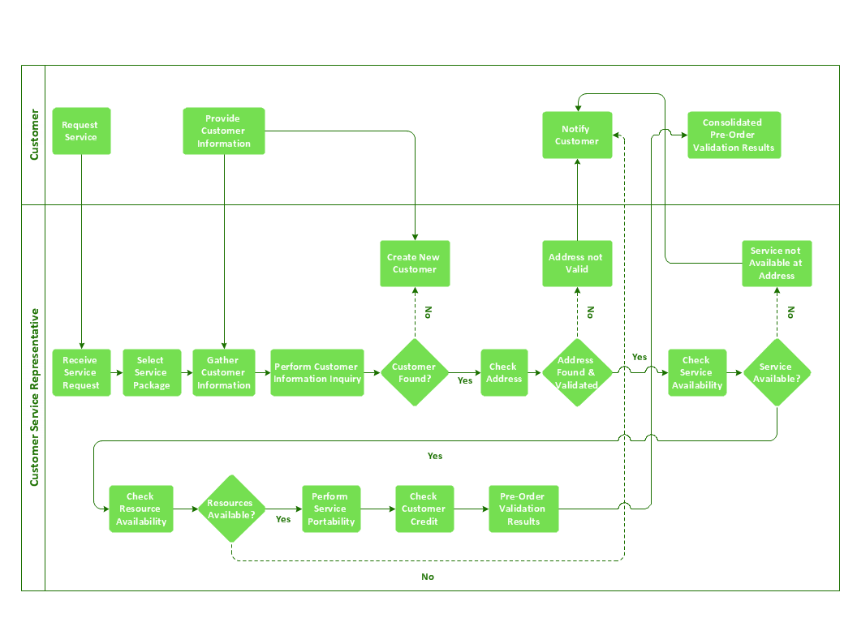

# **MODULE DISTRIBUTION:**

Muhammad Yahya ->

Design and implementation of the core network infrastructure. This includes the development of the routing algorithms, network protocols, and the integration of Security systems.

Muhammad Shoaib Akhter ->

user interface, real-time monitoring tools, and automated management systems, ensuring a efficient network administration.

**REFRENCES:**

"Computer Networking: Principles, Protocols and Practice" by Olivier Bonaventure:

"Data Communications and Networking" by Behrouz A. Forouzan:

"Computer Networks" by Andrew S. Tanenbaum and David J.

<https://www.juniper.net/gb/en/training.html>

<https://www.netacad.com/>

<https://www.telecoms.com/>

https://www.itu.int/en/ITU-T/Pages/default.aspx

**Teacher Signature**: ______________________________________________

**Remarks**: ______________________________________________

**Submission Date**: ______________________________________________